**Module1: Measurement of various process parameters**

### **Contents**

* Measurement of quantities such as temperature, pressure, force, displacement, speed, flow, level, humidity, pH etc.
* Signal conditioning.
* Estimation of errors and calibration.

## **Measurement of temperature**

* It is measurement of the hotness or coldness of a body relative to a standard scale and is related with reference to its power of communicating heat to the surroundings.
* When a body is heated or cooled, various primary effects can result, and one of these effects can be employed for measurement purposes –

1. Change in the physical or chemical state
2. Change in physical dimensions
3. Variation in electrical properties

**Applications:**

* Process controls industry has developed a large number of sensors and devices to handle the demand.
* Industrial environment
* Most mechanical engineers: water temperature of an engine or load device or temperature of a weld in a laser welding application

## **Temperature scale**

* There are three temperature scales in use today, Fahrenheit, Celsius and Kelvin.
* These scales are based on the number of increments between freezing point and boiling point of water at the standard atmospheric temperature.

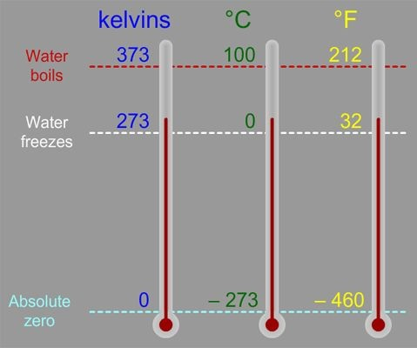**Measurement of temperature**

* **Thermocouple**
* **Thermistor**
* **Thermometer**
* **RTD**

## **Thermocouple**

* Device which is used for the measurement of temperature variations
* Active transducers: The active transducers generate electric current or voltage directly in response to stimulation.

**Principle:**

* Thermocouple is composed of atleast two metals joined together to form two junctions.
* Common thermocouple materials include copper/constantan (Type T), iron/constantan (Type J), and chromel/alumel (Type K).
* Hot junction/measuring junction- unknown body
* Cold/reference junction- known temperature

Seebeck effect-

* This effect states that when two different or unlike metals are joined together at two junctions, an electromotive force(emf) is generated at the two junctions.
* The amount of emf generated is different for different combinations of metals.

Peltier effect-

When two dissimilar metals are joined together to form two junctions, emf is generated within the circuit due to the different temperatures of the two junctions of the circuit.

## **Working**

* Thermocouple measures the voltage generated between the two junctions.
* In thermocouple, the emf set up is measured by sending a current through the moving coil instrument, the deflection being directly proportional to the emf.
* The reference junction is usually at 0 °C.
* 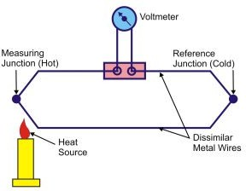Thermocouples- upto 1400 °C.

**Choice of metals used for the thermocouple**

* + Temperature range
  + 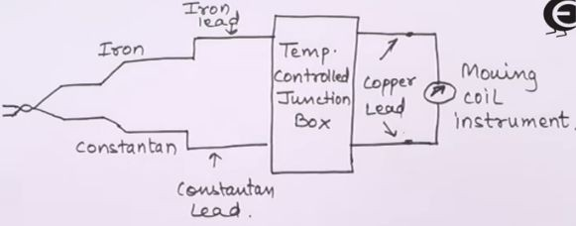Atmosphere

## **Advantages**

* + It is rugged in construction
  + Covers a wide temperature range
  + Using extension leads and compensating cables, long transmission distances for temperature measurement possible. This is most suitable for temperature measurement of industrial furnaces.
  + Comparatively cheaper in cost
  + Calibration can be easily checked
  + Offers good reproducibility
  + High speed of response

## **Limitations**

* + Lower accuracy
  + Should be protected against contamination(stray magnetic and electric fields) to ensure long life
  + Placed at remote locations from the measuring devices
  + In many applications, amplification of signal is required.

**Thermistors**

* + A thermistor is a type of resistor with resistance varying according to its temperature. The resistance is measured by passing a small, measured direct current through it and measuring the voltage drop produced. There are basically two broad types
  + NTC-Negative Temperature Coefficient: used mostly in temperature sensing
  + PTC-Positive Temperature Coefficient: used mostly in electric current control.

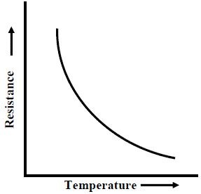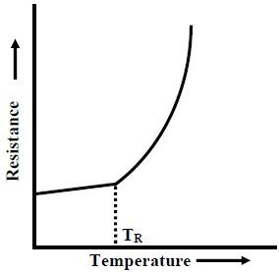 **PTC thermistor NTC thermistor**

**Construction-**

1. Thermistors are fabricated from semiconductor materials which include the oxides of copper, manganese, nickel, cobalt
2. 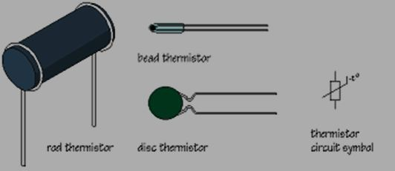These oxides are blended in a suitable proportion and compressed into desired shapes from powders and heat treated to recrystallize them, resulting in a dense ceramic body with the required R – T characteristics.

**Advantages:**

* + They are simple and easy owing to their small sizes.
  + Their cost is low.
  + They are highly sensitive.
  + They can be adapted to various electrical read outs. With the help of computers thermistors can be easily used for accurate temperature measurement.

**Disadvantages:**

* + The temperature vs resistance curve of thermistors are highly nonlinear.
  + It is not rugged and requires delicate handling which limits its application.
  + They are susceptible to self-heating errors.
  + Their range is limited to few hundred degree Celsius.
  + Thermistors use semiconductors which are prone to permanent de-calibration (drifting out of their specified nature).

## **Liquid in glass thermometer**

* + The volume of mercury changes slightly with temperature; the small change in volume drives the narrow mercury column a relatively long way up the tube.

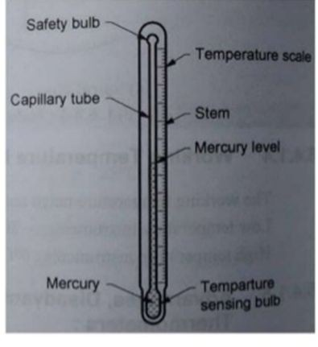

**Construction**

* + A bulb which acts as a container for the functioning liquid(Mercury, Alcohol, Pentene, Toluene) where it can easily expand or contract in capacity.
  + A stem, “a glass tube containing a tiny capillary connected to the bulb and enlarged at the bottom into a bulb that is partially filled with a working liquid”.
  + A temperature scale which is basically preset or imprinted on the stem for displaying temperature readings.
  + Point of reference i.e. a calibration point which is most commonly the ice point.
  + A working liquid which is generally either mercury or alcohol.
  + An inert gas, mainly argon or nitrogen which is filled inside the thermometer above mercury to trim down its volatilization.

# Advantages

* + They are comparatively cheaper than other temperature measurement devices.
  + Unlike electrical thermometers, they do not necessitate power supply or batteries for charging.
  + They can be frequently applied in areas where there is problem of electricity.
  + They provide very good repeatability and their calibration remains unaffected.

**Limitations**

* + They are considered inapt for applications involving extremely high or low temperatures.
  + They can not be applied in regions where highly accurate results are desirable.
  + As compared to electrical thermometers, they are very weak and delicate. Therefore, they must be handled with extra care because they are likely to break.
  + Besides, they can not provide digital and automated results. Hence, their use is limited to areas where only manual reading is adequate, for example, a household thermometer.
  + “Temperature readings should be noted immediately after removal because a glass thermometer can be affected by the environmental temperature, heat produced by the hand holding it, cleaning, etc. This temperature should be recorded because a glass thermometer does not offer a recall of the measured temperature.”
  + Reading temperature via liquid-in-glass thermometers call for brilliant eyesight.
  + Liquid element contained in a glass thermometer may be perilous or risky to health owing to their potential chemical spills.
  + These thermometers display temperature either in Celsius or Fahrenheit scales. Thus, temperature conversion would be needed if the temperature reading is wanted in some other scale.

## 

**Resistance temperature** detectors(RTD)

* + Principle- The resistance of a conductor changes when a temperature is changed.
  + The variation of resistance R with temperature T can be represented by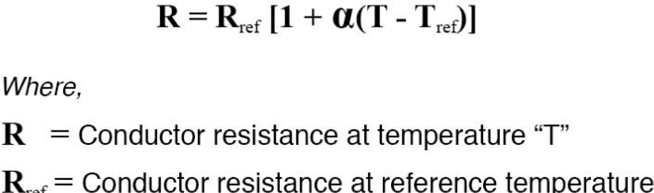

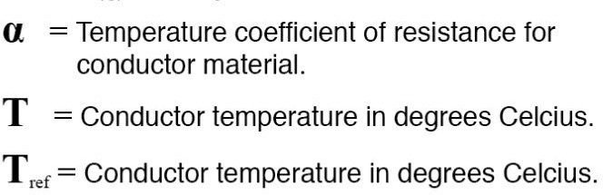

* + In RTD devices; Copper, Nickel and Platinum are widely used metals. These three metals are having different resistance variations with respective to the temperature variations. Platinum has the temperature range of 650oC, and then the Copper and Nickel have 120oC and 300oC respectively.
  + 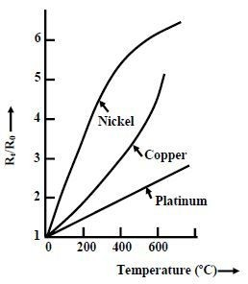Positive temperature coefficient
  + Platinum

1. Withstand high temperature
2. Excellent stability
3. Less susceptible to contamination
4. 100 Ohm at 0°C with a resistance temperature coefficient of **0.00385/°C**
   * The construction is typically such that the wire is wound on a form (in a coil) on notched mica cross frame to achieve small size, improving the thermal conductivity to decrease the response time and a high rate of heat transfer is obtained.
   * Mica is placed in between the steel sheath and resistance wire for better electrical insulation.
   * 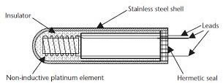In the industrial RTD’s, the coil is protected by a stainless steel sheath or a protective tube.

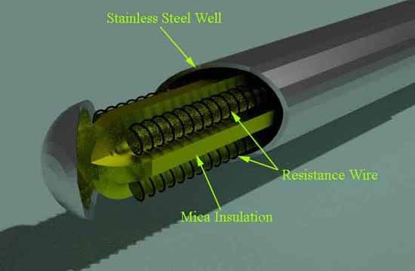

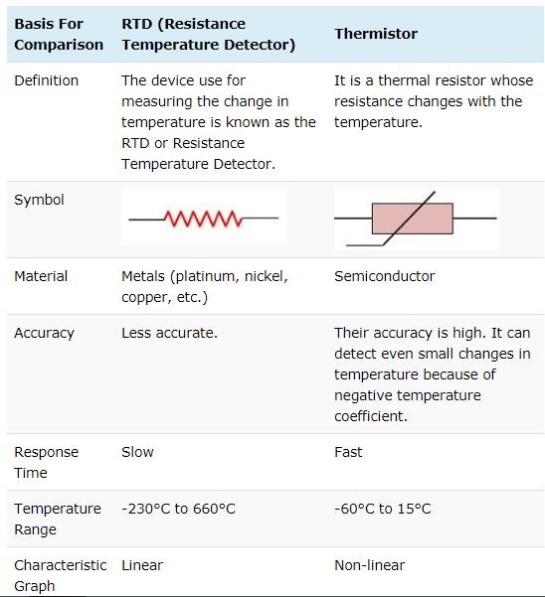

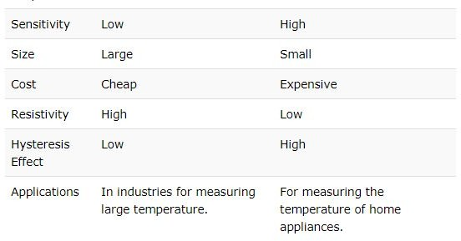**RTD Thermistor**

**Measurement of pressure**

* + Most pressure sensors used in process control result in the transduction of pressure information into a physical displacement.
  + Measurement of pressure requires techniques for producing the displacement and means for converting such displacement into a proportional electrical signal.
  + Diaphragms
  + Bellows
  + Bourdon Tube

## **Diaphragm**

* + One common element used to convert pressure information into a physical displacement is the diaphragm (thin, flexible piece of metal)
  + If a pressure p1 exists on one side of the diaphragm and p2 on the other, then a net force is exerted given by

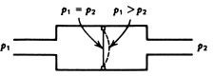

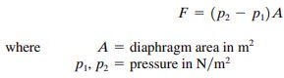

* + A diaphragm is like a spring and therefore extends or contracts until a Hooke’s law(F=-kx) force is developed that balances the pressure difference force.
  + Notice that since the force is greater on the p1 side of the diaphragm, it has deflected toward the p2 side. The extent of this deflection (i.e., the diaphragm displacement) is a measure of the pressure difference.
  + Methods to detect diaphragm deflection

1. Mechanically coupled indicating needle
2. LVDT(Linear Variable Differential Transducer)
3. Strain Gauge
4. Other velocity or displacement sensors

## **Bellows**

* + The accordion-shaped sides of the bellows are made from thin metal(stainless steel, brass,bronze etc.). When there is a pressure difference, a net force will exist on the flat, front surface of the bellows.
  + The bellows assembly will then collapse like an accordion if p2 is greater than p1 or expand if p2 is less than p1.
  + We have a displacement which is proportional to pressure difference. This conversion of pressure to displacement is very nearly linear. t. Here an LVDT is used to convert the displacement to voltage amplitude.

###### **Bourdon Tube**

* A hard metal tube, usually a type of bronze or brass, is flattened, and one end is

closed off. The tube is then bent into a curve or arc, sometimes even a spiral.

* 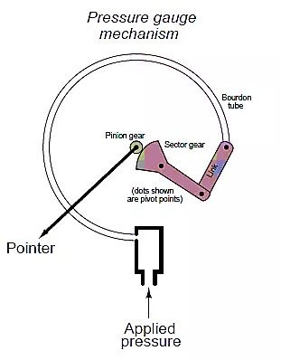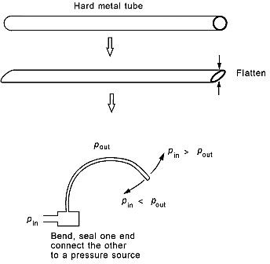The open end is attached to a header by which a pressure can be introduced to the inside of the tube. When this is done, the tube will deflect when the inside applied pressure is different from the outside **pressure.**
  + The tube will tend to straighten out if the inside pressure is higher than the outside pressure and to curve more if the pressure inside is less than that outside.
  + Most of the common, round pressure gauges with a meter pointer that rotates in proportion to pressure are based on this sensor. In this case, the deflection is transformed into a pointer rotation by a system of gears.
  + Of course, for control applications, we are interested in converting the deflection into an electrical signal. This is accomplished by various types of displacement sensors to measure the deflection of the Bourdon tube.

## **Measurement of level**

* + Mechanical type
  + Electrical type
  + Ultrasonic type

**Mechanical Type- Float**

* One of the most common techniques for level measurement, particularly for liquids, is a float that is allowed to ride up and down with level changes.
* This float is connected by linkages to a secondary displacement measuring system such as a potentiometric device or an LVDT core.

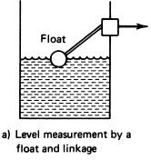

### **Electrical type- Capacitive**

* + Two concentric cylinders are contained in a liquid tank. The level of the liquid partially occupies the space between the cylinders, with air in the remaining part.
  + This device acts like two capacitors in parallel, one with the dielectric constant of air and the other with that of the liquid. Thus, variation of liquid level causes variation of the electrical capacity measured between the cylinders.

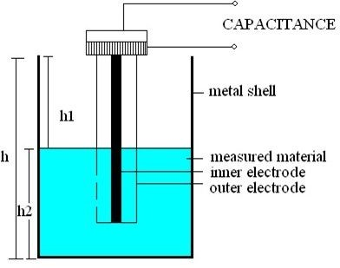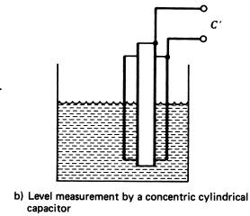

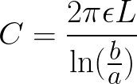 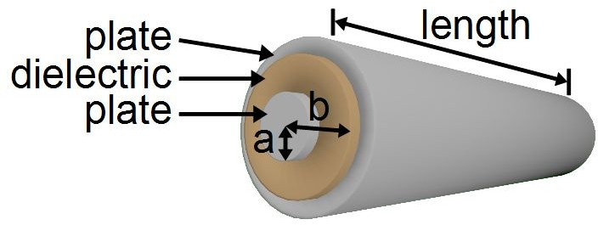

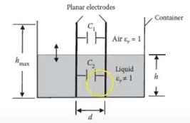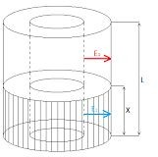

##### **Ultrasonic type**

* + Figure shows the external and internal techniques. Obviously, the external technique is better suited to solid-material level measurement. In both cases, the measurement depends on the length of time taken for reflections of an ultrasonic pulse from the surface of the material.

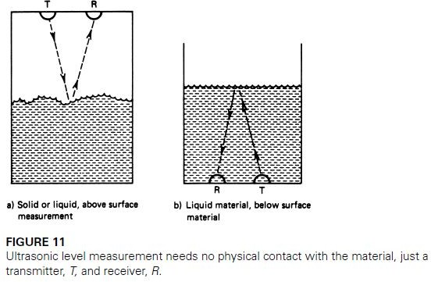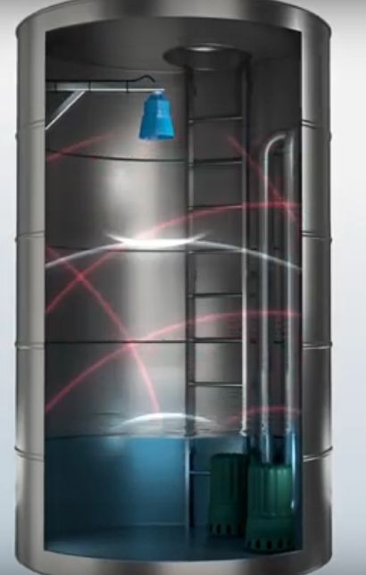

## **Measurement of Flow**

* + Venturi meter
  + Orifice meter
  + Rotameter
  + Vortex Tube
  + Pitot Tube

## **Venturi meter**

**Construction-**

* Short converging part: It is a tapered portion whose radius decreases as we move forward.
* Throat: It is middle portion of the venturi. Here the velocity of the fluid increases and pressure decreases. It possesses the least cross section area.
* 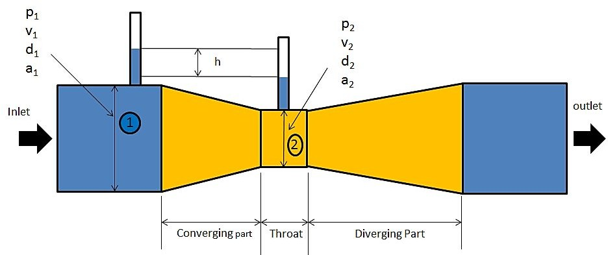Diverging part: In this portion the fluid diverges.

#### Bernoulli's equation

* Bernoulli's principle states that an increase in the speed of a fluid occurs simultaneously with a decrease in pressure or a decrease in the fluid's potential energy.
* Bernoulli's principle can be derived from the principle of conservation of energy . This states that, in a steady flow, the sum of all forms of energy in a fluid along a streamline is the same at all points on that streamline. This requires that the sum of kinetic energy , potential energy, and internal energy remains constant.
  + Thus an increase in the speed of the fluid – implying an increase in its kinetic energy (dynamic pressure) – occurs with a simultaneous decrease in (the sum of) its potential energy (including the static pressure) and internal energy.
  + According to the Venturi effect, a fluid's pressure decreases as its velocity increases.



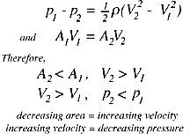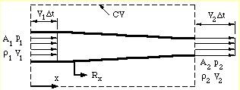

## **Working**

* + As the water enters at the inlet section i.e. in the converging part it converges and reaches to the throat.
  + The throat has the uniform cross section area and least cross section area in the venturi meter. As the water enters in the throat its velocity gets increases and due to increase in the velocity the pressure drops to the minimum.

|  |  |  |
| --- | --- | --- |
| Now there is a pressure difference of the fluid at the two sections. At the section 1(i.e. at the inlet) the pressure of the fluid is maximum and the velocity is minimum. And at the section 2 (at the throat) the velocity of the maximum and the pressure is minimum. | fluid | is |
| * The pressure difference at the two section can be   the manometer attached at both the section. | seen | in |

* + This pressure difference is used to calculate the rate flow of a fluid flowing through a pipe.

## **Orifice Meter**

* + An Orifice Meter is basically a type of flow meter used to measure the rate of flow of Liquid or Gas, especially Steam, using the Differential Pressure Measurement principle.
  + As the name implies, it consists of an Orifice Plate which is the basic element of the instrument. When this Orifice Plate is placed in a line, a differential pressure is developed across the Orifice Plate. This pressure drop is linear and is in direct proportion to the flow-rate of the liquid or gas.

**Construction**:

* **Inlet Section**

A linearly extending section of the same diameter as the inlet pipe for an end connection for an incoming flow connection. Here we measure the inlet pressure of the fluid / steam / gas.

* **Orifice Plate**

An Orifice Plate is inserted in between the Inlet and Outlet Sections to create a pressure drop and thus measure the flow. The Orifice plates in the Orifice meter, in general, are made up of stainless steel of varying grades.

* **Outlet Section**
* A linearly extending section similar to the Inlet section. Here also the diameter is the same as that of the outlet pipe for an end connection for an outgoing flow. Here we measure the Pressure of the media at this discharge.
* As shown in the adjacent diagram, a gasket is used to seal the space between the Orifice Plate and the Flange surface, prevent leakage.

Sections 1 & 2 of the Orifice meter, are provided with an opening for attaching a differential pressure sensor (u-tube manometer, differential pressure indicator).

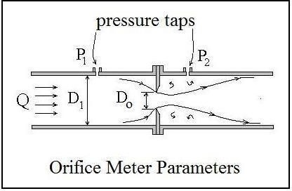

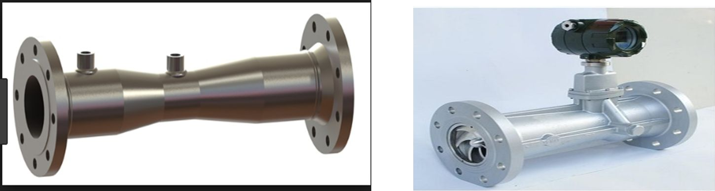

## **Operation**

* The fluid flows inside the Inlet section of the Orifice meter having a pressure P1.
* As the fluid proceeds further into the Converging section, its pressure reduces gradually and it finally reaches a value of P2 at the end of the Converging section and enter the Cylindrical section.
* The differential pressure sensor connected between the Inlet and the and the Cylindrical Throat section of the Orifice meter displays the difference in pressure (P1-P2). This difference in pressure is in direct proportion to the flow rate of the liquid flowing through the Orifice meter.
* Further the fluid passed through the Diverging recovery cone section and the velocity reduces thereby it regains its pressures. Designing a lesser angle of the Diverging recovery section, helps more in regaining the kinetic energy of the liquid.

## **Rotameter**

* + A rotameter is made up of a tapered tube and a float inside it. The glass tapered tube has a scale on the surface or a scale is placed adjacent to it, according to purpose.
* Tapered tube:
* The tapered tube is placed vertically in the flow channel with a conical shape inside. The quantity measured is defined by the height of float going up. Glass tubes are used for both liquid and gas measurement. Metallic tubes are used where the process fluid with high temperature and pressure.
* Float:
* Stainless steal floats are commonly used, there are different types of metals from lead to aluminium used as floats. A float material, shapes are also varied according to applications considering density.
* Spherical shape floats are used for small flows.
  + Fluid enters from the bottom of the tapered tube, then some of the fluid strikes directly into the float bottom and others pass aside the float. Now the float experience two forces in opposite direction, darg force upward and gravitational force downward.
  + Fluid flow moves the float upward against gravity.At some point, the flowing area reaches a point where the pressure-induced force on the floating body exactly matches the weight of the float. The float will find equilibrium when the area around float generates enough drag equal to weight - buoyancy.
  + As the float weight and gravity are constant, the distance float displaced upward is proportional to the flow velocity of the fluid passing through the tapered tube.

## **Measurement of speed**

* + Optical sensor
  + Tachometer

**Optical Sensor Working**

* 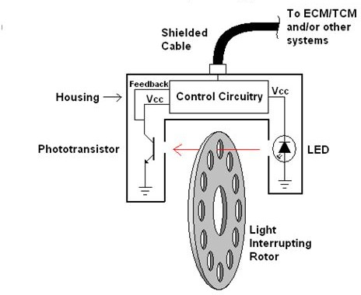An opaque disc with perforations or transparent windows at regular intervals is mounted on the shaft whose speed is to be measured.
* A LED source is aligned on one side of the disc in such a way that its light can pass through the transparent windows of the disc. As the disc rotates the light will alternately pass through the transparent windows and be blocked by the opaque sections.
* On the rotation of the disc, holes and opaque portions of the disc come alternately in between the light source and the light sensor. When a hole comes in between the two, light passes through the holes and falls on the light sensor, with the result that an output pulse is generated. But when the opaque portion of the disc comes in between, the light from the source is blocked and hence there is no pulse output. Thus whenever a hole comes in line with the light source and sensor, a pulse is generated. These pulses are counted/measured through an electronic counter.
* A photo detector fixed on the other side of the disc detects the variation of light and the output of the detector after signal conditioning, which is a square wave whose frequency is decided by the speed and the number of holes(transparent windows) on the disc.

## **Tachometer**

* + The word tachometer is derived from two Greek words: tachos means “speed” and metron means “to measure”.
  + A tachometer is a sensor device for measuring the rotation speed of an object such as engine shaft in a car . It indicates the number of revolutions per minute(RPM) performed by an object. Types of tachometer commonly available:-
  + Analog Tachometer :- Comprises needle and dial type interface.
  + Digital Tachometer :- Comprises LCD or LED readout and a memory.
  + Contact/Non-Contact tachometer :- Sensor is in directly contact with rotating shaft in case of contact type.
  + Time/Frequency measuring tachometer :-Time measuring device calculates speed by measuring time b/w incoming pulses whereas frequency measuring devices measures the frequency of incoming pulses.

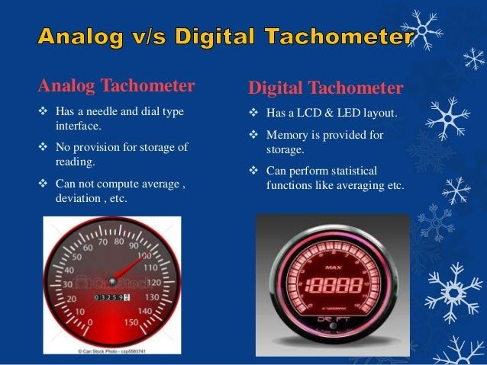

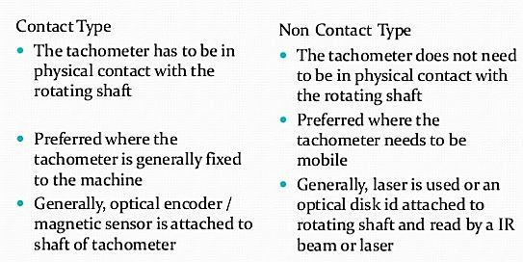

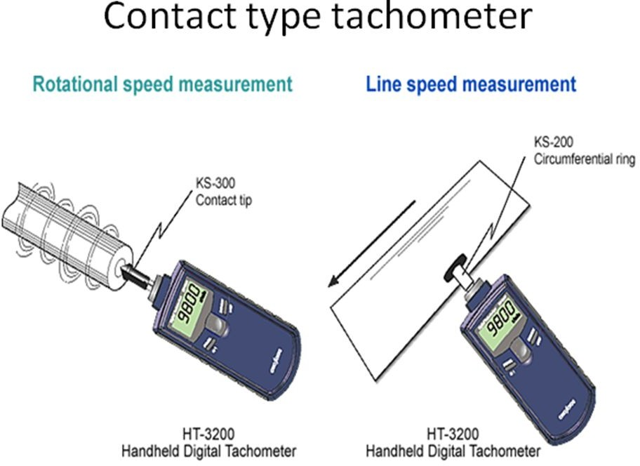 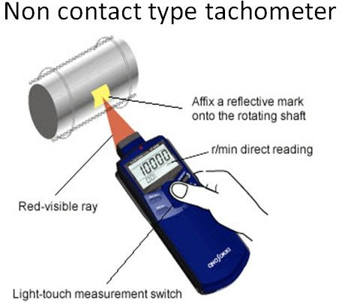

## **Measurement of displacement**

* LVDT-Linear Variable Differential Transformer, LVDT is the most used inductive transducer for translating linear motion into electrical signal. This transducer converts a mechanical displacement proportionally into electrical signal.

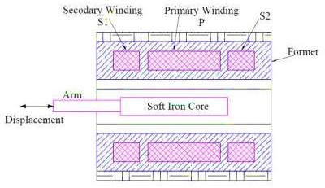

#### Construction

* LVDT is a transformer consisting of one primary winding P and two secondary winding S1 & S2 mounted on a cylindrical former. The two secondary winding

have equal number of turns and placed identically on either side of the

primary winding as shown in figure.

* A movable soft iron core is placed inside the former. The movable core is made of nickel iron with hydrogen annealed. Hydrogen annealing is done to eliminate harmonics, residual voltage of core and thus provides high sensitivity. The movable core also is laminated in order to reduce eddy current loss. The assembly of laminated core is placed in a cylindrical steel housing and end lids are provided for electromagnetic and electrostatic shielding. The displacement to be measured is attached to this movable soft iron core.

# Working Principle of LVDT:

* + 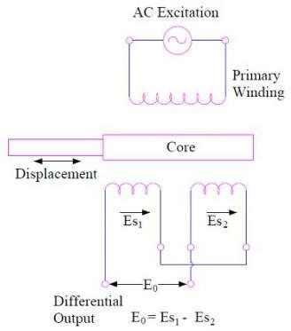Since the primary winding of Linear Variable Differential Transformer (LVDT) is supplied with AC supply, it produces an alternating magnetic flux in the core

which in turn link with the secondary winding S1 and S2 to produce emf due to transformer action.

* + Let us assume that the emf produced in secondary winding S1 is Es1 and that in S2 is Es2. The magnitude of Es1 and Es2 will depend upon the magnitude of rate of change of flux (dØ / dt) as per the Faraday’s Law.
* To get a single output voltage from the Linear Variable Differential Transformer (LVDT), both the secondary winding are connected in series but in phase opposition as shown in figure. Due to this connection, the net output voltage E0 of the LVDT is given as **E0 = Es1 – Es2**
* Since the secondary windings of LVDT are identical and placed symmetrically on either side of core, therefore under normal position the flux linkage of both the secondary winding S1 &

S2 will be same. This means Es1 = Es2 and hence net output

voltage E0 of LVDT = 0. This position of soft iron core is called NULL position. Thus NULL position of Linear Variable Differential

Transformer is the normal position of movable core where the net output voltage is zero.

* Now, as the core can either be moved toward right or left to the null position. Let us now consider such movement of core under two cases.

# Working of LVDT:

* **Case-1**: Core is moved left to the NULL position

When core of LVDT is moved to the left of the NULL position ‘0’ as shown in figure, the flux linkage of secondary winding S1 will become more than that of winding S2. This means the emf induced in winding S1 will be more than S2. Hence Es1 > Es2 and net output voltage

E0 = (Es1 – Es2) = Positive.

* **Case-2:** Core is moved right to the NULL position

When the core of LVDT is moved toward right of NULL position ‘0’, the emf induced in secondary winding S2 will be more than that of S1. This means Es2 > Es1 and hence net output voltage E0 = (Es1 – Es2) = negative.

**From the above two cases, we can have the following conclusions:**

1. The direction of movement of a physical quantity can be identified by the output voltage of LVDT. If the output voltage E0 is positive, this means the physical quantity is moving toward left.
2. If the output voltage E0 is negative, this will mean that the physical quantity is moving in the right direction from the NULL position.
3. The amount / magnitude of displacement is proportional to the magnitude of output voltage. The more the output voltage, the more will be displacement.

## **Application**

* LVDT is used in those applications where displacement ranging from fraction of a mm to few cm is to be measured. As a primary transducer, it converts the mechanical displacement into electrical signal.
* Acting as a secondary transducer, it is used for measurement of force, pressure, weight etc.

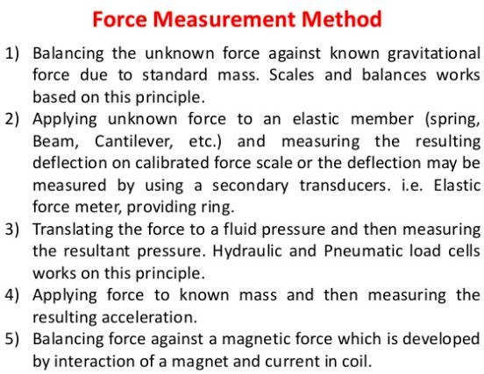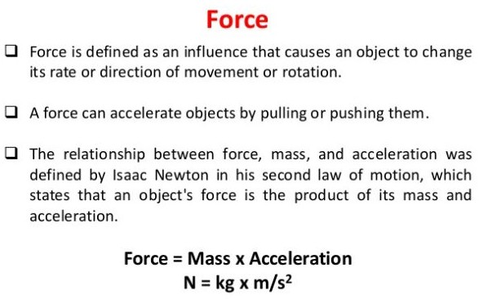

## **Measurement of humidity**

* Humidity measurement finds wide applications in different process industries. Moisture in the atmosphere must be controlled below a certain level in many manufacturing processes. e.g. textiles, papers,cereals must be dried to standard storage conditions in order to prevent quality detoriation.
* Humidity measurement can be done with the help of hygrometer, psychrometer, dew point measurement, capacitance method, IR technique(satellites), humidistat etc.

**Hygrometer**

* Due to humidity, several materials experience a change in physical, chemical and electrical properties. This property is used in transducer that are designed and calibrated to read relative humidity directly.
* Certain hygroscopic materials such as human hair, animal membranes, wood, paper, etc., undergo changes in linear dimensions when they absorb moisture from their surrounding air. This change in linear dimension is used as the measurement of humidity present in air.

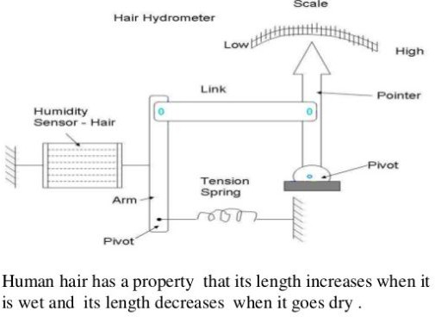**Measurement of pH**

pH is the measure of the hydrogen ion

concentration in a solution. It describes the degree of acidity

or alkalinity (basicity) of a solution.

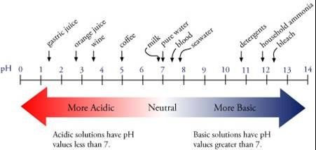

* 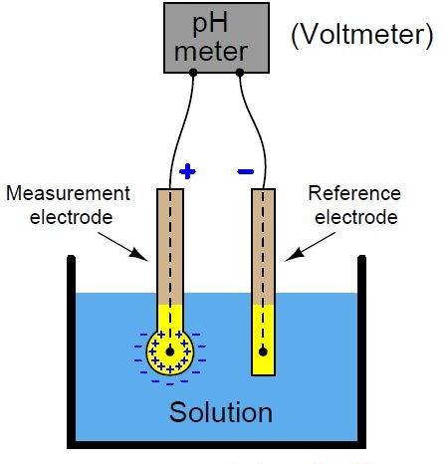The pH value of a solution is measured using a pH electrode. It consists essentially of a pair of electrodes, measurement and reference electrode, both submerged in the solution of unknown pH.
* These two electrodes essentially form two half cells. Although the potential developed in the reference cell is constant, the potential of the measurement cell depends on

the concentration of hydrogen ions in the solution.

**Applications of pH measurement:**

* + For the diagnosis of various disorders in the human body
  + Pharmaceutical
  + Agriculture
  + Corrosion prevention
  + Dyeing
  + Printing

## **Signal Conditioning**

* + Signal conditioning circuits are used to process the output signal from sensors of a measurement system to be suitable for the next stage of operation

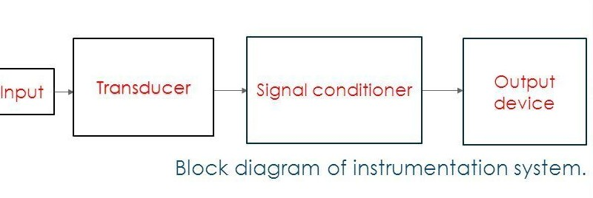

* + The function of the signal conditioning circuits include the following items:

1. Signal amplification (Op-amp)
   * Increase the level of input signal.
   * Improve the sensitivity and resolution of the

measurement.

1. Filtering (Op-amp)
   * Reject useless noise within certain frequency range.
   * Prevent signal aliasing and distortion.
2. Interfacing with µP (ADC)
3. Protection (Zener & photo isolation)
4. Linearization, Current – voltage change circuits, resistance change circuits (Wheatstone bridge), error compensation
5. Attenuation
   * Contrary to amplification.

## **Estimation of errors and calibration**

* The measurement error is defined as the difference

between the true or actual value and the measured value.

The error may arise from the different source and are usually classified into the following types. These types are

* Gross Errors
* Systematic Errors
* Random Errors
  + Gross Error

The gross error occurs because of the human mistakes. Such type of error is very common in the measurement. The complete elimination of such type of error is not possible. Some of the gross error easily detected by the experimenter but some of them are difficult to find. Careful reading and recording of the data can reduce the gross errors to a great extent.

* **Systematic Errors**

The systematic errors are mainly classified into three categories.

1. Instrumental Errors
2. Environmental Errors
3. Observational Errors
   * Random Errors

The error whose cause is not clearly known and they affect the readings in a random way are known as random errors.

## **Calibration**

The accuracy of all measuring devices degrade over time. This is typically caused by normal wear and tear. However, changes in accuracy can also be caused by electric or mechanical shock or a hazardous manufacturing environment. In order to ensure that the instrument reading will give the actual value within reasonable accuracy, calibration is required at frequent intervals.

## **Benefits of Calibration**

* It fulfills the requirements of traceability to national / international standards like ISO 9000, ISO 14000 etc.
* As a proof that the instrument is working.
* Confidence in using the instruments.
* Traceability to national measurement standard.
* Interchangeability.
* Reduced rejection, failure rate thus higher return.
* Improved product and service quality leading to satisfied customers.
* Power saving.
* Cost Saving.
* Safety.